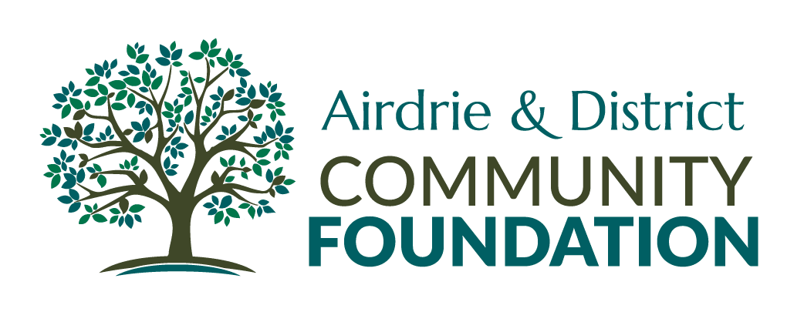

Suite 944, 203 - 304 Main Street S.E. Airdrie, AB T4B 3C3
403 -285-1858

Grant Application

The Airdrie & District Community Foundation is a community catalyst committed to being a vehicle for individuals, businesses and organizations to participate in the creation of an enduring legacy.
Guiding Principles of the ADCF

A Community Catalyst
We work with community and for community by supporting organizations that demonstrate a collaborative approach. We support innovative projects that align with our guiding principles. Not every new idea will work, but we will learn from every project.

Quality of Life
We are committed to strengthening the quality of life in Airdrie and the surrounding area. We build on the strengths of the community and address issues that detract from community well-being by supporting organizations that share this goal with us.

Stewardship
We are building a community legacy because we never touch our capital pool of money. While our capital base grows, we use the income earned to support community. We are committed to investing wisely, managing efficiently and looking for ways to maximize resources and results through alliances and partnerships.

Proactive Attitude
The Foundation does not necessarily wait for applications. Through strong community relationships we identify and address issues with other community organizations and district municipalities.

Volunteer Support
Programs that utilize a strong volunteer force or are dedicated to supporting volunteers will be a priority for Foundation support.

Independence for Individuals
Community development means building the capacity of individuals to be independent and self-sustaining. We will give strong consideration to projects that support this principle.
Application Process

- Please contact the Chair at the Airdrie & District Community Foundation to discuss your proposal before completing the application package.

- Only QUALIFIED DONEES*, as defined by the Income Tax Act (Canada), are eligible for Foundation grants. Non-Qualified Donees must contact the Foundation for further information

- The Board will not consider applications for deficit funding of projects.

- Grants are typically awarded in April or May. The application deadline is March 15 in any calendar year.

- A complete grant package must be submitted electronically to treasurer@airdriefoundation.ca on or before the submission deadline. A complete grant application will include the following:
An original copy of:
  - The Application Form set out below.
  - Audited financial statements (as per your organization’s by-laws).
  - Evidence of Charitable status with Canada Revenue Agency (front page of your T3010).
  - Certificate of Incorporation.
  - Original signed Declaration of Intent and Statutory Declaration.
- Grant applications submitted after the granting deadline will not be considered and will be returned.

- Grant allocations will be announced approximately six weeks after the grant submission deadline.

- Grant recipients are fully accountable to the Foundation for funds received upon acceptance of the grant. As such, applicants will be required to sign the Declaration of Intent and the Statutory Declaration (see back page) and fulfill the requirements therein.

- To assist us in raising the profile of the Foundation all recipients are required to acknowledge their partnership with the Airdrie & District Community Foundation in all project communications.

• QUALIFIED DONEE as listed in paragraph 110 (1) (a) and (b) of the Income Tax Act (Canada), as amended from time to time and as related to the objects of the Airdrie & District Community Foundation – registered charities, registered Canadian amateur athletic associations; certain housing corporations providing low- cost accommodation to the elderly; Canadian municipalities; the United Nations or agencies thereof; universities outside of Canada as set out in regulations to the Income Tax Act (Canada); charitable organizations outside Canada to which Her majesty in right of Canada has made a gift during the taxpayers taxation year or the 12 months immediately preceding that taxation year; Her Majesty in right of Canada; and Her Majesty in right of a province.

APPLICATION FOR FUNDING
To: Airdrie & District Community Foundation Date:

PART A: ABOUT YOUR ORGANIZATION/GROUP

Please complete the following. Your organization/group may not have some of the information, so if it is not available, plea se indicate “N/A”. Please keep this information brief in order to facilitate funder review.

ORGANIZATION NAME (for the group responsible for accounting funds):

ORGANIZATION ADDRESS:
CONTACT NAME:
CONTACT PHONE NUMBER:
CONTACT FAX NUMBER:
E-MAIL ADDRESS:
INCORPORATION NUMBER:
INCORPORATION DATE:
CHARITABLE DONATION NUMBER:
R R
CHARITABLE ORGANIZATION NAME: EXECUTIVE DIRECTOR (IF APPLICABLE):
NUMBER OF STAFF: FULL TIME
PART TIME
AMOUNT REQUESTED: $

Authorization for application:

NAME: POSITION: SIGNATURE:

NAME: POSITION: SIGNATURE:

A1. GUIDING PRINCIPLES: (these may be thought of as beliefs/values/philosophy)

A2. MISSION/MANDATE: (what your organization/group does. Identify any legislation that governs your mandate)

A3. GOALS OF YOUR ORGANIZATION: (this will encompass the broad view of your total organization/group)

A4. PROGRAMS AND SERVICES: (list the programs and services that are provided, and describe each in one sentence. this will give the funder an overview of your organization/group)

A5. BOARD OF DIRECTORS: (include the names, addresses and phone number of your current board of directors if applicable.)

Please complete the following. Your organization/group may not have some of the information, so if it is not available, plea se indicate “N/A”. Please keep this information brief in order to facilitate funder review.

NAME OF THE PROGRAM/PROJECT/SERVICE/INITIATIVE:

B1. PURPOSE OF THE PROGRAM (what it is intended to do, how will it assist the target population?)

B2. TARGET POPULATION/GROUP (who will be served? where are they located geographically? [state percentage in
Airdrie and other respective communities])

B3. COMMUNITY NEED (why is there a need for this program in the community and how have you determined this need?
WHAT IS THE NEED? WHAT DEMOGRAPHIC INFORMATION OR STATISTICS SUPPORT THE COMMUNITY NEED? ARE OTHERS IN THE COMMUNITY OFFERING A SIMILAR PROGRAM?)

B4. COMMUNITY PARTICIPATION (what resources, strengths or assets already exist that you can build on? what partnerships, linkages or new directions (that you can build on) are in your community? how will volunteers be involved in this program? what opportunity will there be for clients to participate in the planning and delivery of this program?).

B5. OBJECTIVES (what are the specific objectives of this program that relate to the funding that you are requesting this year?).

B6. FITTING YOUR MISSION/MANDATE (how does this program fit your overall organizational/group’s mission/mandate and how does it relate to your organizational/group goals?).
OR
IF THIS APPLICATION IS ON BEHALF OF A PARTNERSHIP OR CONSORTIUM, HOW DOES THE PROGRAM FIT THE APPLICANT’S MANDATE AND GOALS?

B7. HOW WILL IT OPERATE (give a description of how the program will operate. how many staff will be involved; what qualifications do you require? are there entry requirements to the program? if so, what are they? where will the program operate from?).

B8. MEASUREMENT TO ENSURE ACCOUNTABILITY (how will you know if you have been successful with your target population? what measures will you use and what will they tell us about outcomes? how will you report to the funder? (i.e. monthly).

FUNDING

B9. HOW DOES THIS PROGRAM FIT WITH THE MANDATE OF THE FUNDER, I.E., PREVENTION, EARLY INTERVENTION, ETC. - AS APPROPRIATE.

B10. INDICATE ANY OTHER FUNDERS FOR THIS PROGRAM. WILL YOU BE FUNDRAISING FOR PART OF THE OPERATING EXPENSES, AND IF SO, HOW MUCH? (OPERATING EXPENSES INCLUDE BOTH ADMINISTRATION AND PROGRAM COSTS)

B11. PROVIDE A BUDGET SPECIFIC TO THE PROGRAM/PROJECT/SERVICE, INITIATIVE YOU ARE REQUESTING FUNDING, AND INDICATE VERY CLEARLY HOW MUCH FUNDING YOU ARE REQUESTING.

Please provide financial statements

DECLARATION OF INTENT:
(to be completed by a signing authority of your organization)

As the applicant, I declare that if awarded a grant by the AIRDRIE & DISTRICT COMMUNITY FOUNDATION, it shall be used solely and explicitly for the purposes stated in this application and in accordance with the statement of expenditure (budget) as submitted and approved. Any portion of the grant funds not used for these purposes, or any portion not required to complete the project or meet the described objectives, will be returned to the AIRDRIE & DISTRICT COMMUNITY FOUNDATION, unless prior written permission to vary these purposes is obtained from the Foundation.

I agree to provide, within 60 days of project completion:
_ a report detailing the use to which the funds were applied.
_ copies of all publicity and/or printed materials associated with the project
_ a detailed statement of revenues and expenditures
_ any other relevant information as may be required by the Foundation to satisfy their accounting requirements.

As a condition of accepting assistance from the AIRDRIE & DISTRICT COMMUNITY FOUNDATION. I agree to permit an auditor appointed by the Foundation or recipient to examine all books and records having any connection with the monies received.

Applicant signature:

Print name and position:

Signed at: Date: 20

STATUTORY DECLARATION:

In the matter of a grant request for (name of project)

I, (name) of (address), _(postal

code) in the _(city/town) in the Province of Alberta, do solemnly declare that I, as (official position "the applicant") am the person designated to receive and disburse funds on behalf of (registered name of organization)

and that all statements made or presented by me in this application are true, and knowing that it is of the same force and effect as if made under oath and by virtue of the Canada Evidence Act.

Applicant Signature
DECLARED before me in the )

of )
in the Province of Alberta this day of , 20 A.D.)

) A commissioner for Oaths/Notary Public
For the Province of Alberta

MY APPOINTMENT EXPIRES

